|  |  |
| --- | --- |
|  | **FPT ACADEMY INTERNATIONAL**  **FPT – APTECH COMPUTER EDUCATION** |

**Centre Name: ACE-HCMC-2-FPT.**

**Address: 590 Cach Mang Thang 8, District 3, Ho Chi Minh City, Viet Nam.**

Auto World Ltd

|  |  |  |
| --- | --- | --- |
| **Supervisor.** | Phạm Thị Lánh | |
| **Batch.** | T1.2111.M1 | |
| **Group.** | Group 4 | |
| **Serial No.** | **Enrolment Number** | **Student Name** |
| 1. | Student1350801 | Nguyễn Tuấn Lộc |
| 2. | Student1347641 | Đỗ Minh Quốc |

March 2022

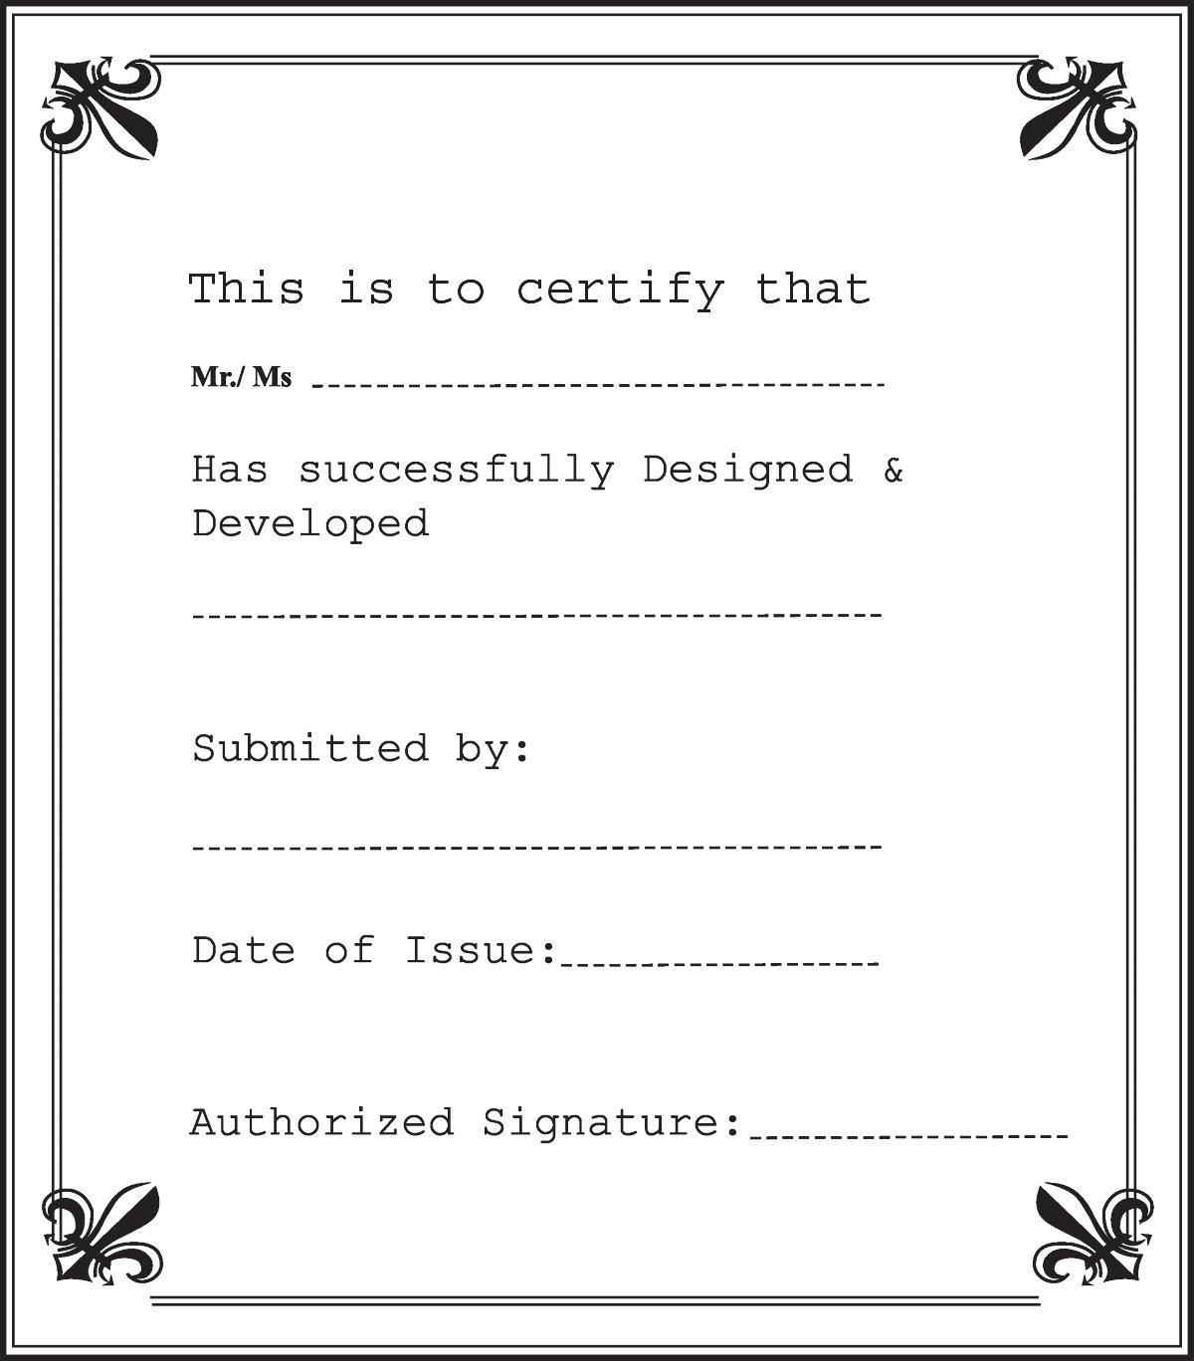

**Contents**

1 ACKNOWLEDGEMENT 4

2 SYNOPSIS 5

3 REVIEW 1 5

3.1 REQUIREMENT SPECIFICATION 6

3.2 PROBLEM DEFINITION 7

3.3 CUSTOMERS REQUIREMENT SPECIFICATION (CRS) 7

3.4 ARCHITECTURE & DESIGN OF THE SYSTEM 11

3.5 SITEMAP 12

3.6 WEBSITE LAYOUT 13

3.6.1 HOMEPAGE 13

3.6.2 CONTACT US 16

3.6.3 CART AND PAYMENT 18

3.7 TASK SHEET 1 20

4 PROJECT SNAPSHOTS 21

4.1 Home Page 21

4.2 Product Details Page 22

4.3 Contact Us: 24

4.4 Footer: 25

4.5 Cart and Payment: 25

4.6 Financial Support: 27

4.7 Login and Sign Up: 28

5 TASK SHEET 2 29

6 CHECKLIST VALIDATION 30

7 REFERENCES 31

# 1 ACKNOWLEDGEMENT

The world is a better place thanks to people who want to develop and lead others. What makes it even better are people who share the gift of their time to mentor future leaders. We would like to acknowledge all those who have given us their support and knowledge sharing in the making of this project.

We wish to express our gratitude to the e-Project Team at the Head Office in India, who provided us with guidance and instructions. We would like to thank all the staff members at the Center in India for providing us the opportunity to work on this project and offering us their upmost encouragement through out the process.

We would like to express our special thanks of gratitude to our instructor, Mrs. Pham Thi Lanh at the Aptech Computer Education HCMC for her able guidance and support in completing our project. We would also like to extend our gratitude to the staff at the Aptech HCMC office for providing us with all the facility that was required.

Our acknowledgement to several people whom also helped with: the collections of pictures samples, CSS & JS libraries, the preparation of web development, sample code snippets and tutorials and they are all thanked for their contributions. Special mentions goes to the contributors of Bootstrap 4, the contributors and admins for tutorials sites such as W3C school, Tutorialspoint.com, GeeksforGeeks, and many other learning sites.

And Lastly, to our many friends and family, you should know that your support and encouragement was worth more than we can express on paper. Thank you to our moms and dads for breakfasts, lunch and dinners – we could not have finished the project without being provided with love and daily nourishments.

# SYNOPSIS

AutoWorld is a company that deals with all types of cars and motors. They started off with a company in collaboration with "GOOD YEAR” and then build up their own establishment. They have different showrooms for different brands at various locations in the city and because of their services they have attracted a vast number of Customers in very short duration of time.

Many times people make calls in the office for getting the information as:

1. Which latest car models are available?
2. What are the salient features of ‘Accord’?
3. Price list for the cars.
4. What about the warranty / insurance of the car?
5. Which is better model: Corolla/Civic/Wagon R?
6. What are the available modes of payment?

And many more like these. The company has tie-up with certain banks in the city with the help of these it assists customers in arranging for the loan. The loan amount is fixed and it is 60% of the price.

You are supposed to create a website for them with the below mentioned requirement specifications:

The website is to be developed to provide certain features according to specific requirements by the management.

The website is to be developed for the Windows Platform using HTML5, JavaScript and Geolocation. The site should work well in all leading browsers including Chrome, IE, Firefox etc.

# REVIEW 1

## REQUIREMENT SPECIFICATION

***AutoWorld.com*** needs to be constructed considering following requirements:

1. Home page which will brief about the company, also design a suitable logo and include it on home page, you may display the logo on all the pages in the site.
2. A menu which will include all the functions implemented in the site.
3. The user should be able to locate the dealers based on the car brands. e.g. Honda, Suzuki, Ford etc.
4. A catalogue should be provided which will help the users to have a look at car’s image and clicking on the same will display the details about it. The details include features, price, location of the dealer etc.
5. There should be a page for contacting to the company which will include the address, phone and email address. Address of the Company should be displayed using GeoLocation API (eg. GoogleMaps) and the email address which when clicked will invoke the local mail client from where they can send an email.
6. Site should also include the page that will give the information about the warranty schemes on the cars. The scheme will be different for the different brands. You are free to develop your own warranty schemes.
7. There should be a page which will list the banks/organizations which provide finance to purchase from AutoWorld. Clicking on the name of the company, user should be redirected to another page which will give the detailed information about the finance scheme. This information will include the details like the maximum amount which customer will get, interest rate, duration in which the amount can be repaid and the installment to be paid and also the terms and conditions.
8. The site should also include the comparison of different cars (same as well as different brands)
9. The user should be able to search the cars based on companies and price.
10. The information about various cars can be picked up from the internet.
11. The site should have appropriate look and feel suitable to company’s reputation and status.

## PROBLEM DEFINITION

After analyzing the Queries coming in form various Customers mostly are related to information regarding which could be one or all of the follow

1. Which latest car models are available?
2. What are the salient features of ‘Accord’?
3. Price list for the cars.
4. What about the warranty / insurance of the car?
5. Which is better model: Corolla/Civic/Wagon R?
6. What are the available modes of payment?

And many more…

And many more like these. The company has tie-up with certain banks in the city with the help of these it assists customers in arranging for the loan. The loan amount is fixed and it is 60% of the price.

The company aims to break new ground by harnessing the power of technology and revolutionizing processes to make car ownership for the customers a truly enjoyable and hassle-free experience.

So taking into consideration the expanding business, the company planned to host the primary information via ***Autoworld.com***, an Internet Gateway to car dealership.

## CUSTOMERS REQUIREMENT SPECIFICATION (CRS)

* + 1. **Client: Auto World Ltd.**
    2. **Objectives:**
       - Provide a website to display information about products (car, service) categorizing product information according to brands and features.
       - The website should have soothing color with proper logo and images. A menu to show car category and provide clickable links. A brief summary of car features will be show. Users who wish to compare car features across different brands will be able to link to a comparison table in which 5 model of the same brand and 2 of different brands will be show on the table.
       - Users should be able to download information from the site to their computers. If users wish to send us an email or looking for our physical location, users should be able to do so in “Contact Us” page.
       - The keywords are “logo”, “menu”, “images”, “pastel color” “Category”, “Menu for various car brand”, “Menu for features of car”, “Brand”, “Comparison”, “Tabular Information”, “Contact Us” , “Send email”, “Geolocation”....
    3. **Inputs provided by clients:**
       - Click on clickable links from menu, or search menu.
       - Click to clickable links/images in “Products” session to link to third party websites.
       - Click “Compare” buttons for comparison between different car.
       - Click “Download” buttons for downloading doc documents from Autoworld.com .
       - Click “Contact Us” link to link to “Contact Us” webpage.
       - Click “send us an email” to send us email.
    4. **Hardware Requirement:**
       - A minimum computer system that will help you access all the tools in the courses is a Pentium 166 or better
       - 64 Megabytes of RAM or better
    5. **Software Requirement:**
       - Window 7/10 OS or higher
       - HTML5/CSS/JS supporting browsers
       - Visual Studio Code.
       - Bootstrap 4
       - JQuery
       - Notepad editor
    6. **Scope of the Work (in brief):**

Depending on the decision taken by the management regarding the Autoworld application, following are the requirements based on which the software needs to be developed:

* + - * Displaying proper Logo, Images, Menu.
      * A Web-based GUI to be created for displaying hyperlinks and clickable Images. The menu will stay on the left side navigation bar, it is to be closed with a toggle button. The menu will provide links according to car brands and features. There will be links to other pages as well as clickable images to direct Users to third party websites(Honda, Suzuki, Ford).
      * The users can view and visit the links to their favourite brands. When clicked, the hero banner will be changed to display the corresponding brand (Honda, Suzuki, Ford).
      * There will be a modal page for comparison of features, the information will be displayed when users click “compare” button.
      * There will be a “download” button where users can download doc documents from the site.

o A “Contact Us” to be created to provide link to email to users, Our office location will be displayed using Geolocation API embedded in the HTML.

## ARCHITECTURE & DESIGN OF THE SYSTEM

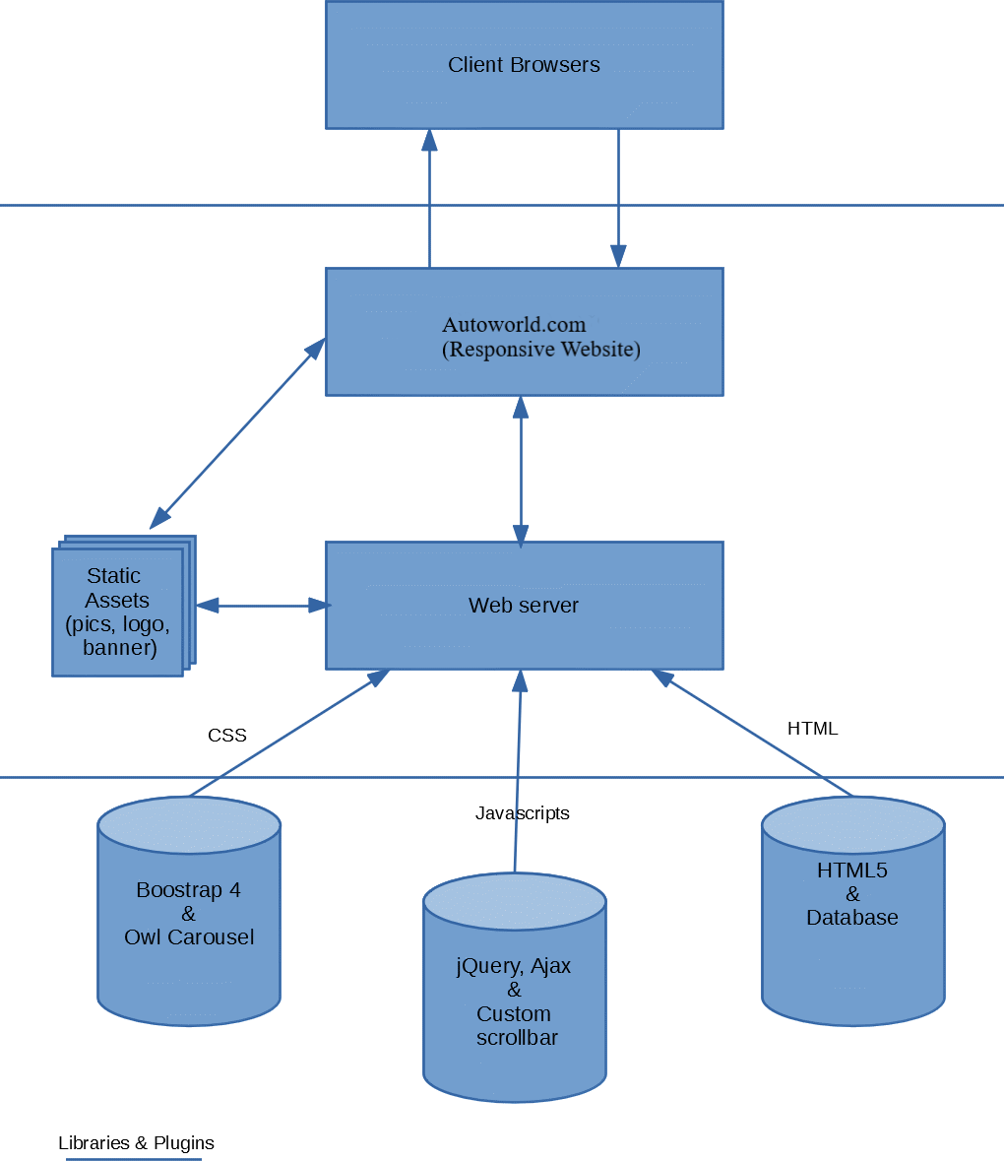

## SITEMAP

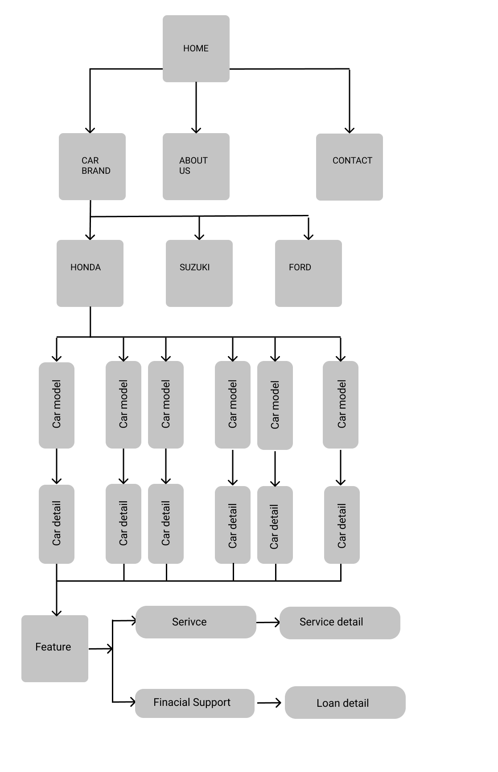

## WEBSITE LAYOUT

The website layout is to be designed with a SIMPLE but ELEGANT design. Because of the objective is to QUICKLY and SYSTEMICALLY deliver information to the site visitors, the main focus of our webpage will be on the main landing page where all the information will be stored and represented. The site users will have a variety of interactions such as performing search function on a search bar, searching using dropdown menus, comparing car features, downloading Word documents, links to third party websites.

The websites will also have a few complimentary pages such as About, Contact Us which contain introductory information about our team and our office address.

### HOMEPAGE

This layout below describes our Home Landing Page which contains three important part:

* The Top navigation bar and Side navigation bar:

There will be two navigation bars to work in synergy. The top bar will have a Hamburger toggle button for the side menu (side panel) and Hyperlinks on the right.

When click to Hamburger button, a side menu will come out from the left screen side, the side menu is the MOST IMPORTANT part of our project since this is where Users will have the most interactions. There will be Our company’s logo on top, and several dropdown menu incorporated within the side panel, a functional search bar, and buttons to link to our Website’s other pages.

* Hero/Jumpotron:

A large Hero banner to populated in the main content area, the banner will be interactive meaning the title and small heading will be changed according to which brand the users currently be viewing.

* Main Content:

A car brand will placed on top of the main content along with a brief description of the car company. Next will be several carousel slide that will showcase the products and features. Each carousel will have several product cards which will contain a brief summary of features and hyperlink buttons.

There will be two hyperlink buttons, a “compare” button and a “download” button. The “compare” button will link to a modal table which will compare current car with 5 car of the same brand and 2 of another brands. The download button will provide a link to download car features in Word Docs.

#### MAIN CONTENT

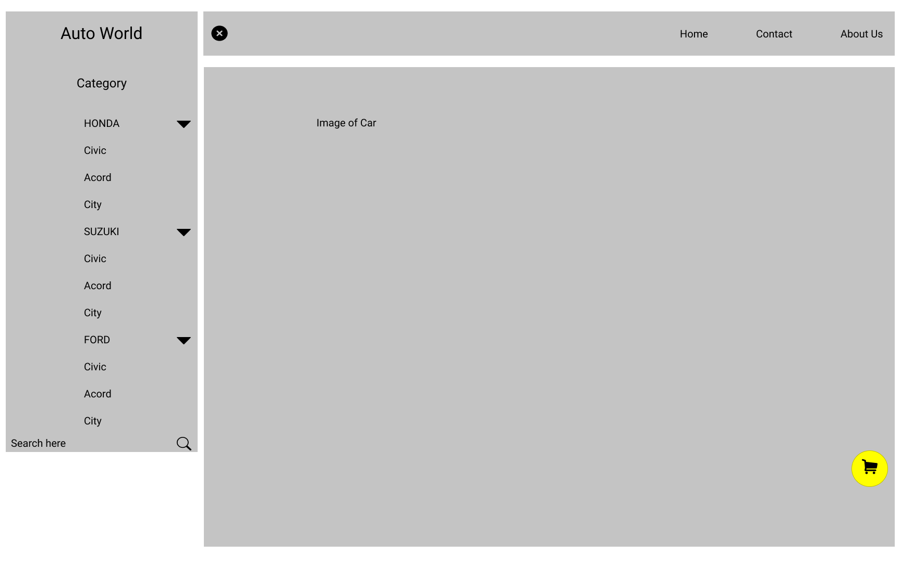

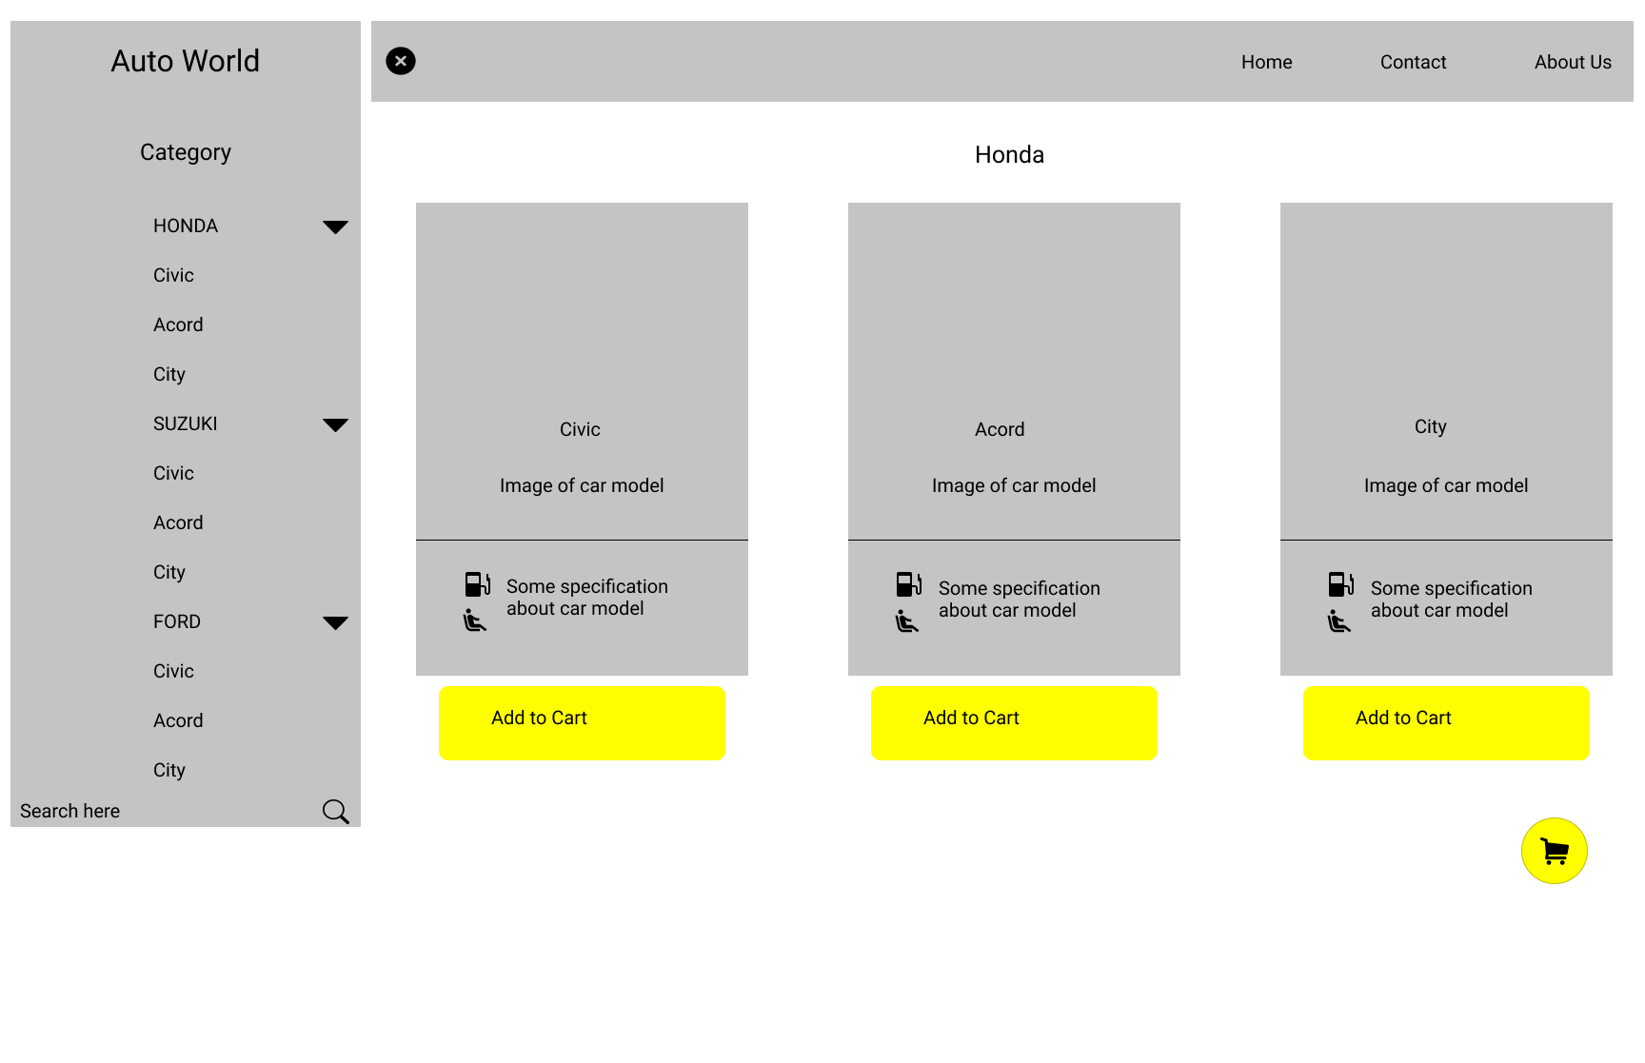

#### CAR DETAIL AFTER CLICK

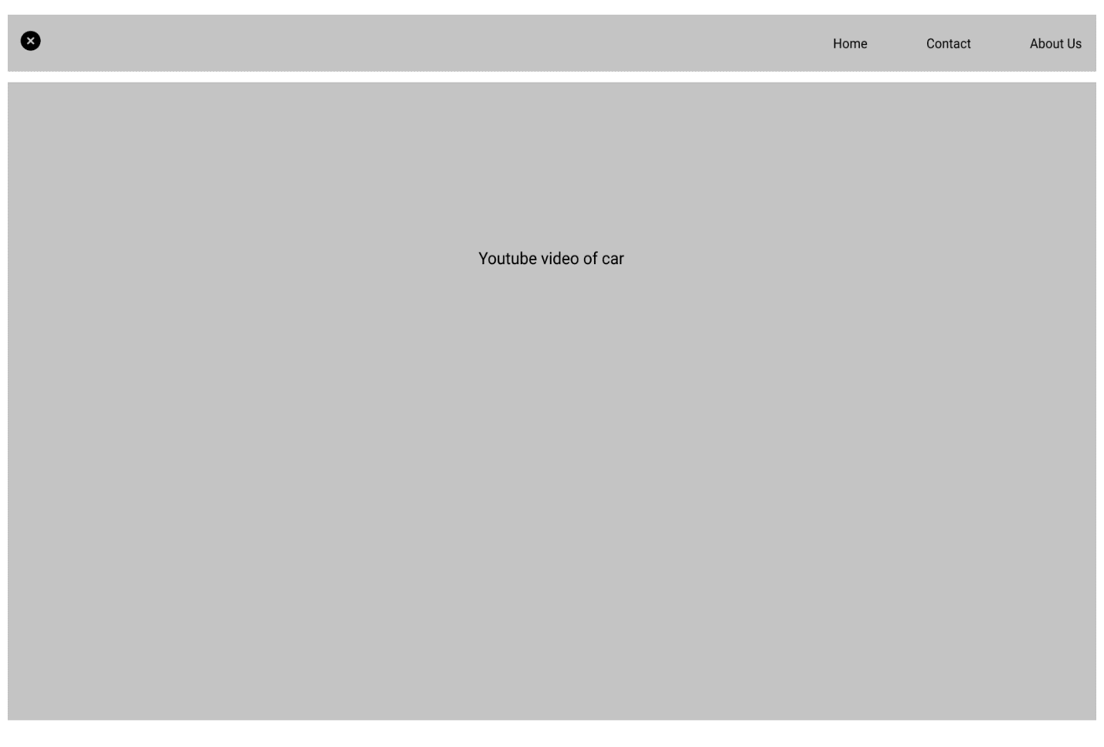

First there will be a video to introduce car, scroll down there is a detail, include add to cart, compare and documentation about that car model.

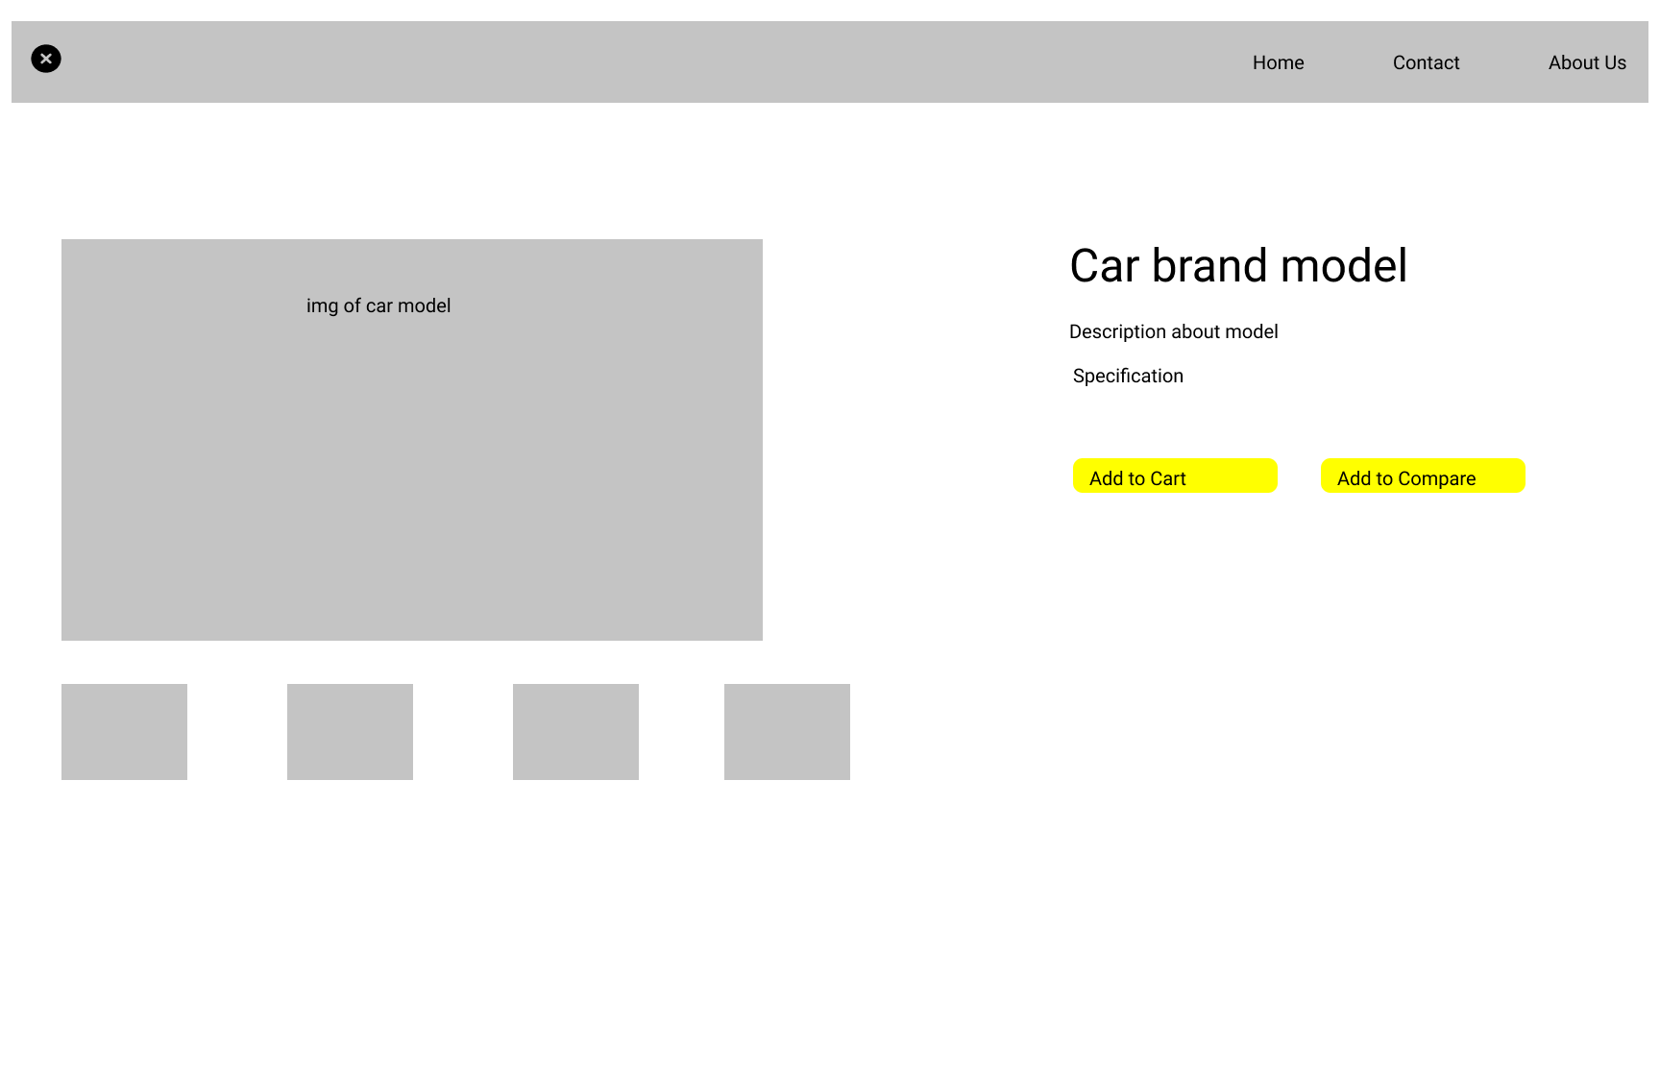

### CONTACT US

The contact us layout will have be simple, there will be a main hero banner on top and below are the headings and email link to our office, a feedback form to be populated using Ajax, and our office address along with a geolocation API showing our office location. The topnav menu will become “Active” to show which page users are currently in.

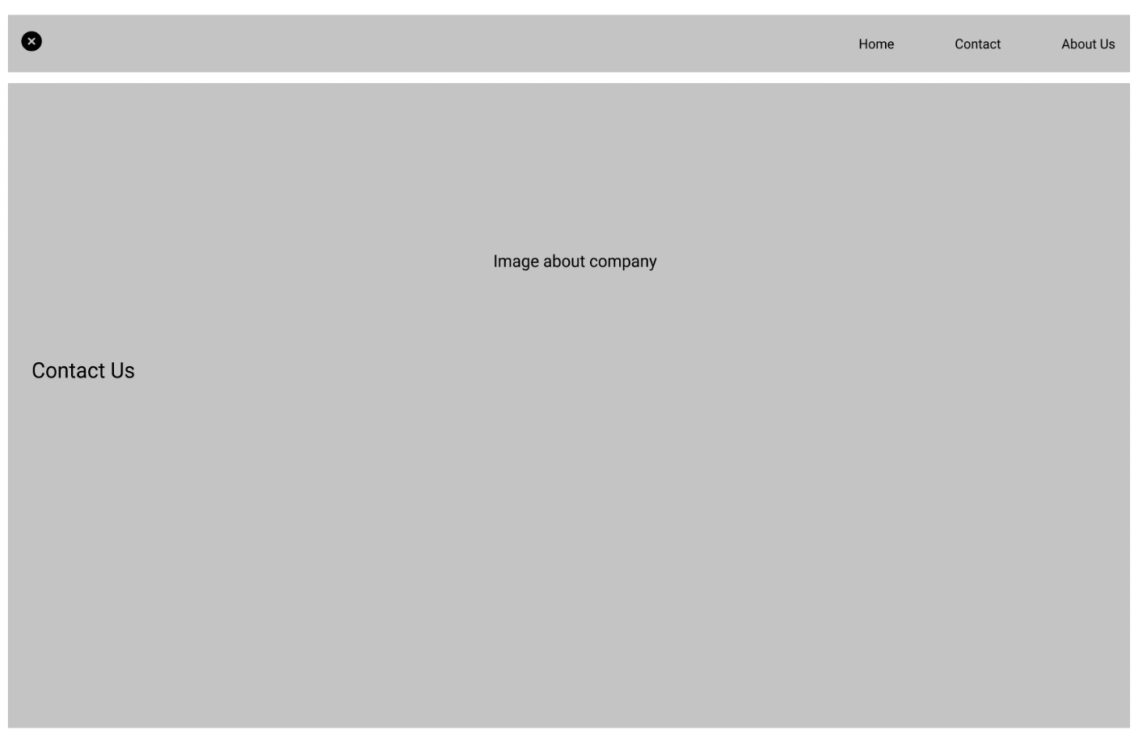

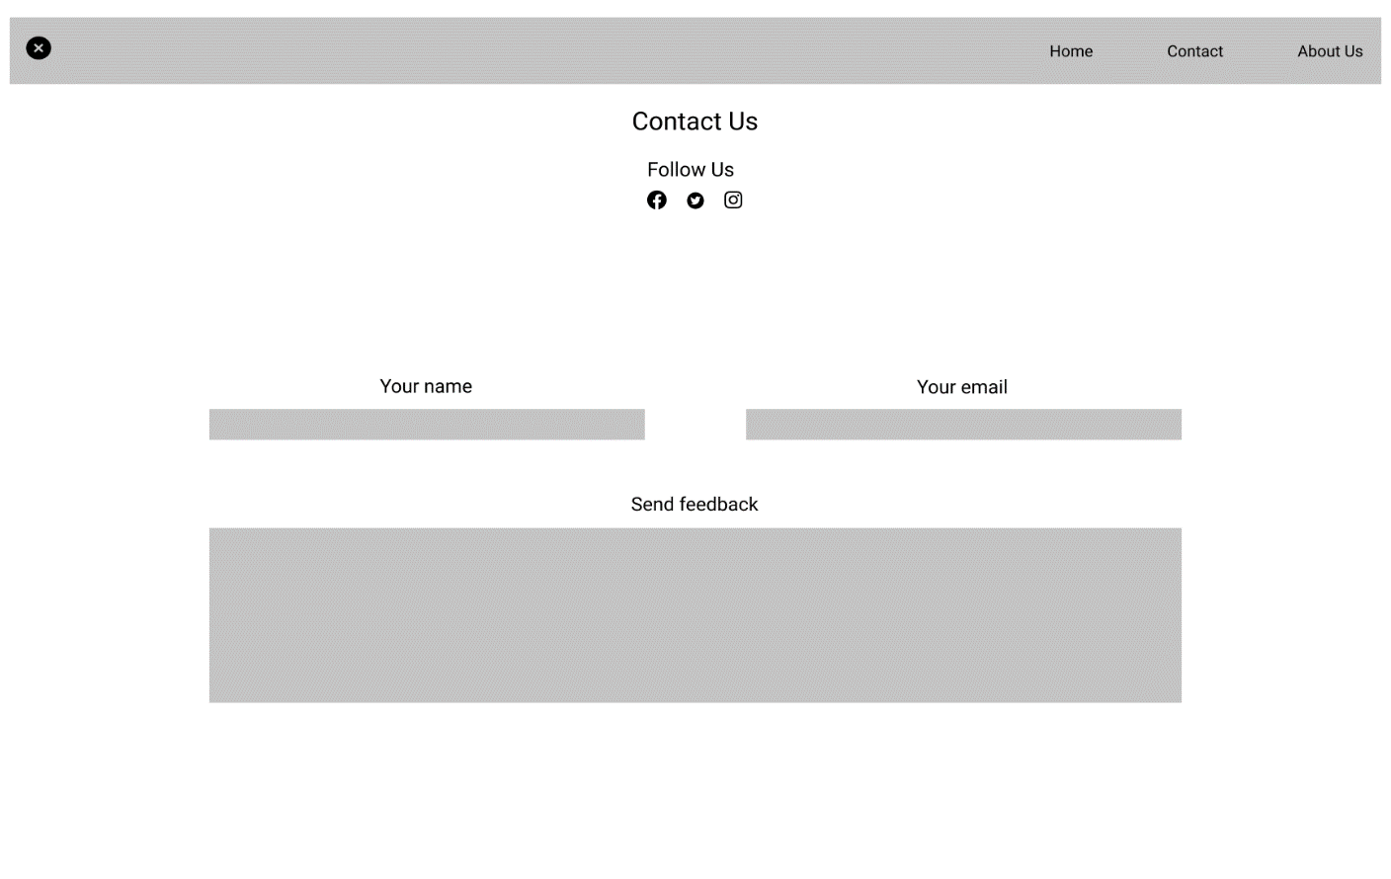

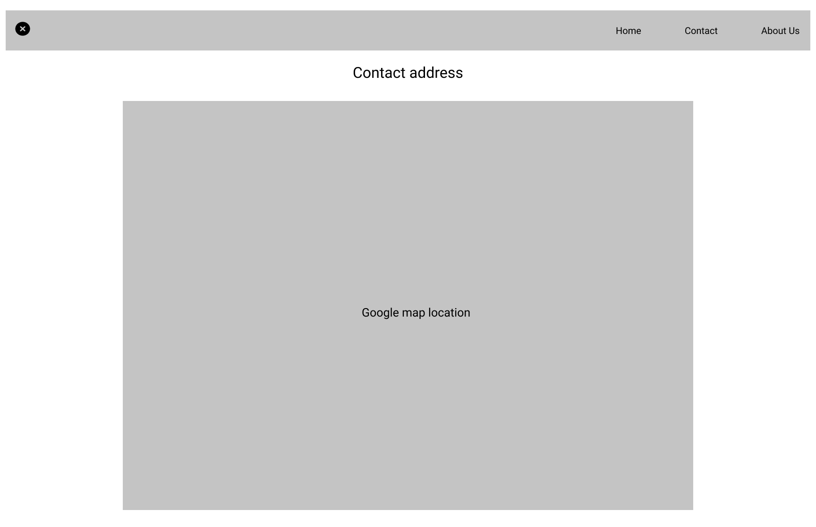

### CART AND PAYMENT

A cart page offers great ease to the user. It allows them to check out everything in one go instead of paying individually for every item they buy. In addition to the ease, users can also save a great deal of time while shopping. It helps a lot, especially if the users are buying multiple items from the website.

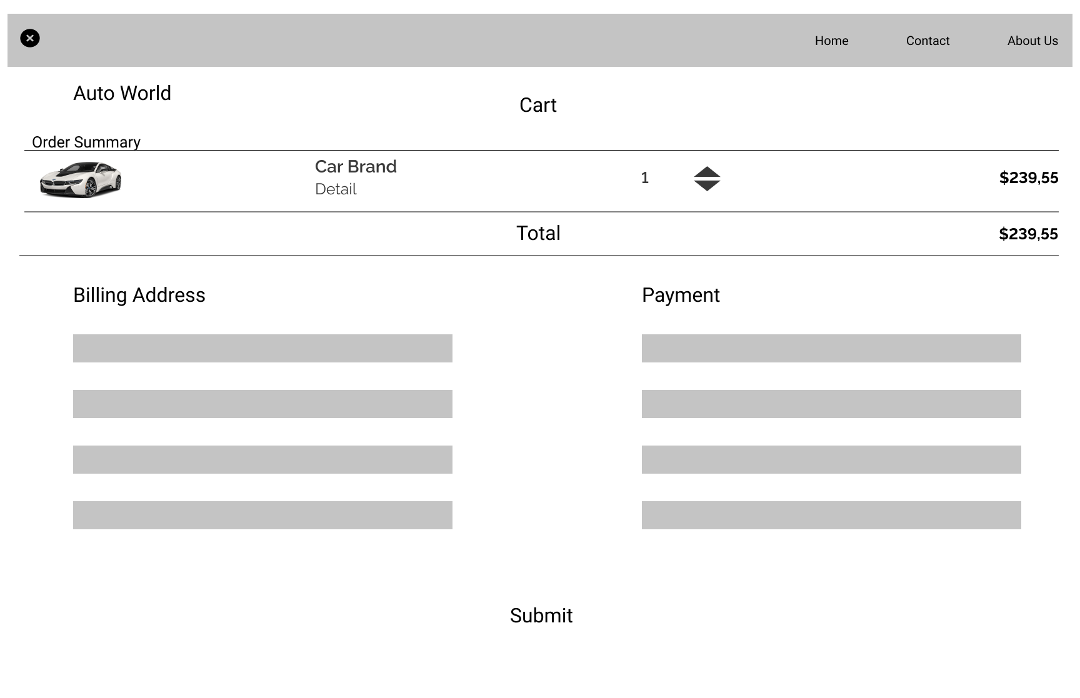

## TASK SHEET 1

|  |  |  |  |  |  |  |
| --- | --- | --- | --- | --- | --- | --- |
| **Project Ref No.** | **Project Title – Auto World** | **Activity Plan Prepared**  **by** | **Date of preparation of Activity Plan** | | | |
| **Task** | **Actual Start Date** | **Actual Days** | **Teammate Names** | **Status** |
| Brainstorming ideas for  layouts, and Project Objective | | Lộc, Quốc | 02/03/2022 | 1 day | Lộc, Quốc | Completed |
| Draw site maps and  architecture design | | Lộc | 02/03/2022 | 1 days | Lộc | Completed |
| Wire framing general page  layout. | | Quốc | 06/03/2022 | 4 days | Quốc | Completed |
| Collect static assets (pictures,  mp4, documentation) | | Lộc, Quốc | 08/03/2022 | 3 days | Lộc, Quốc | Completed |
| Design & Build Home Page | | Lộc, Quốc | 11/03/2022 | 7 days | Lộc, Quốc | Completed |
| Design & Build Contact Us  Page | | Lộc, Quốc | 19/03/2022 | 2 days | Lộc, Quốc | Completed |
| Design & Build About Us Page | | Lộc, Quốc | 21/03/2022 | 2 days | Lộc, Quốc | Completed |
| Design & Build Footer Session | | Lộc, Quốc | 23/03/2022 | 2 days | Lộc, Quốc | Completed |
| Design & Build Product Detail Pages. | | Lộc, Quốc | 25/03/2022 | 2 days | Lộc, Quốc | Completed |
| Write project report Review 1 | | Lộc | 26/03/2022 | 2 days | Lộc | Completed |

|  |  |
| --- | --- |
| Signature of Faculty | Signature of Team Leader |
|  |  |

# PROJECT SNAPSHOTS

## 4.1 Home Page

The following snapshots illustrate the creation of Autoworld.com home page:

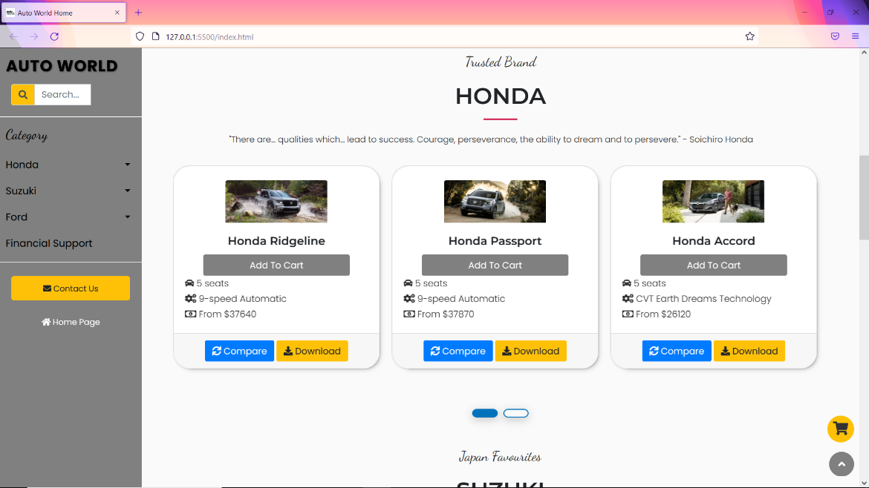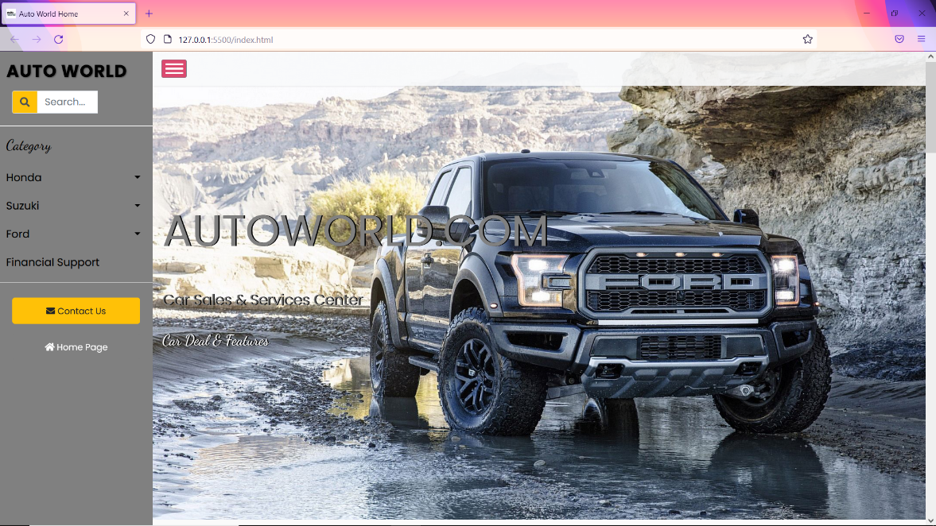

## Product Details Page

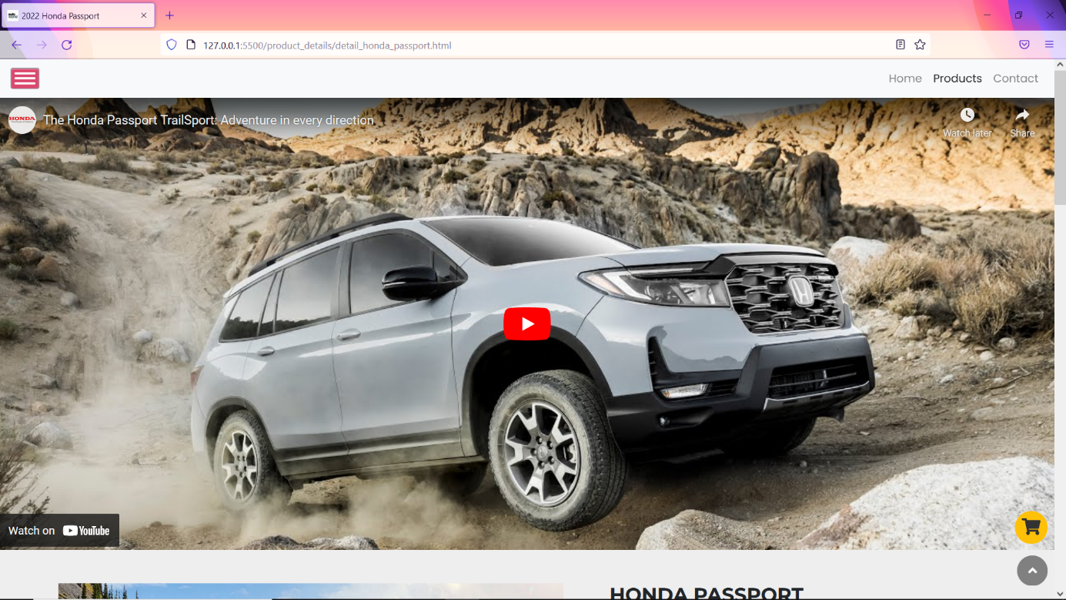

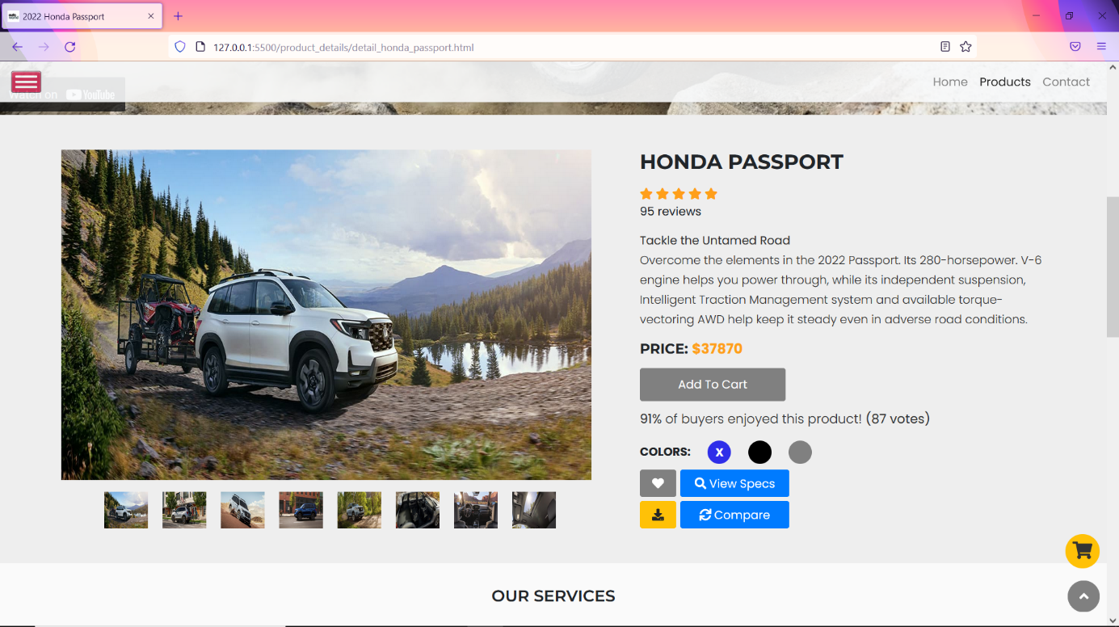

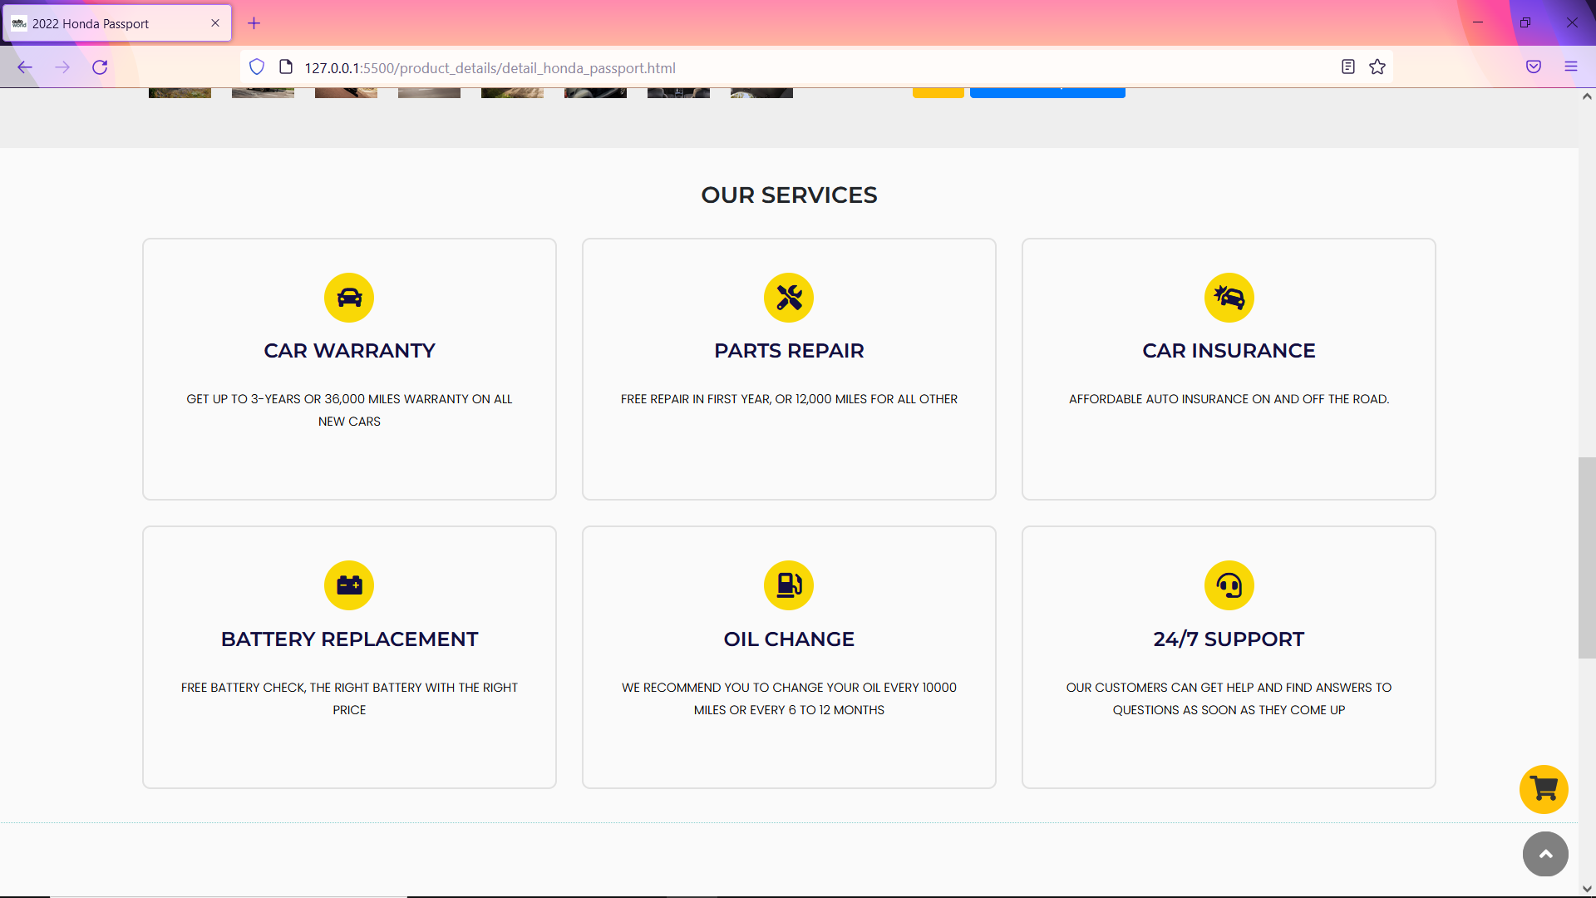

## 4.3 Contact Us:

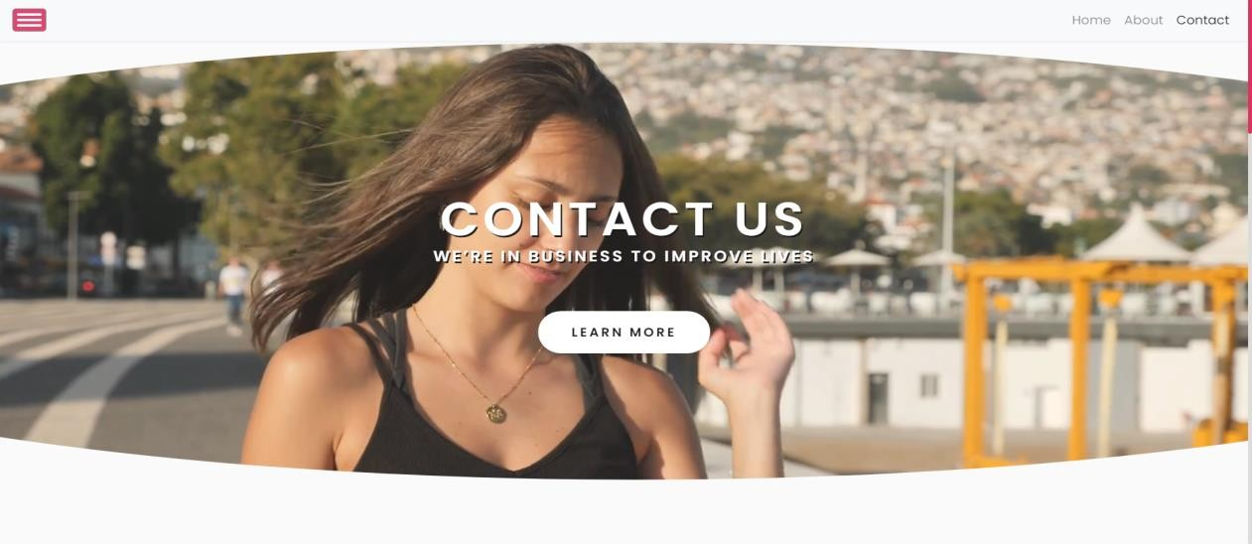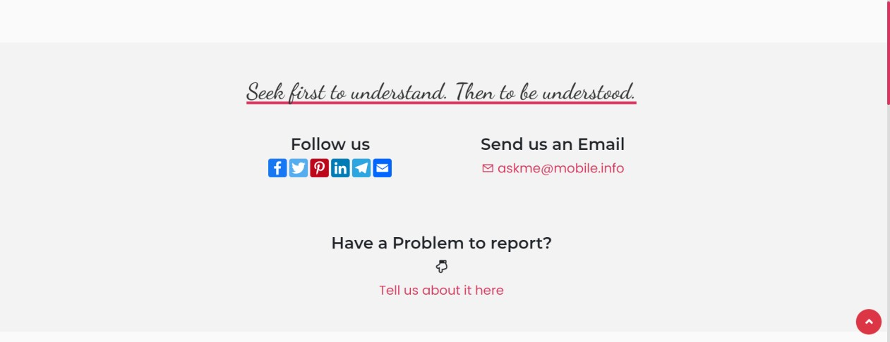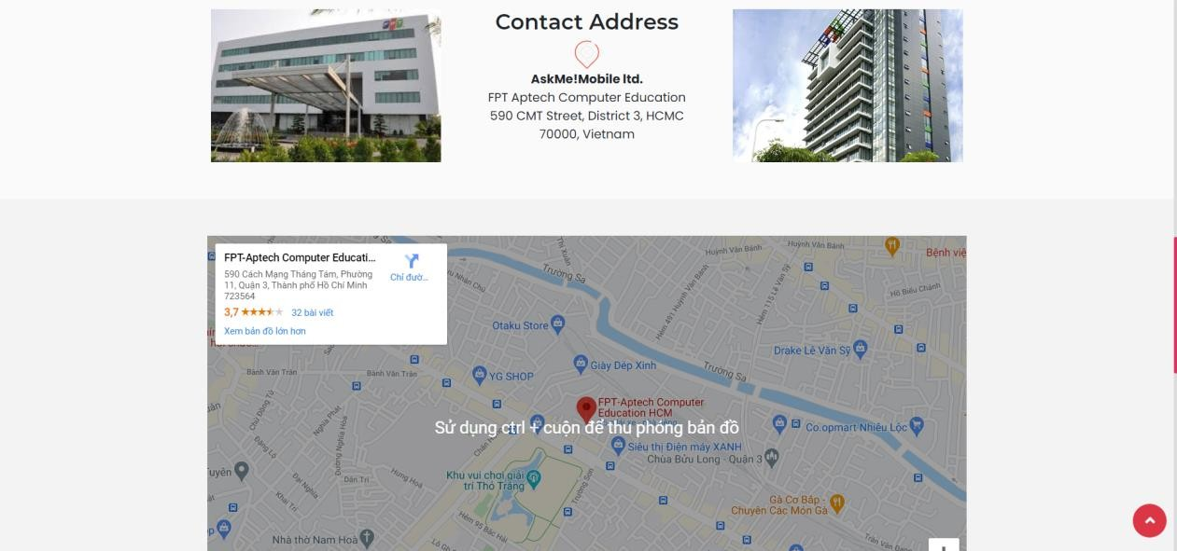The following snapshots illustrate the creation of Autoworld.com contact us page:

## 4.4 Footer:

The following snapshot illustrates the creation of Autoworld.com footer session:

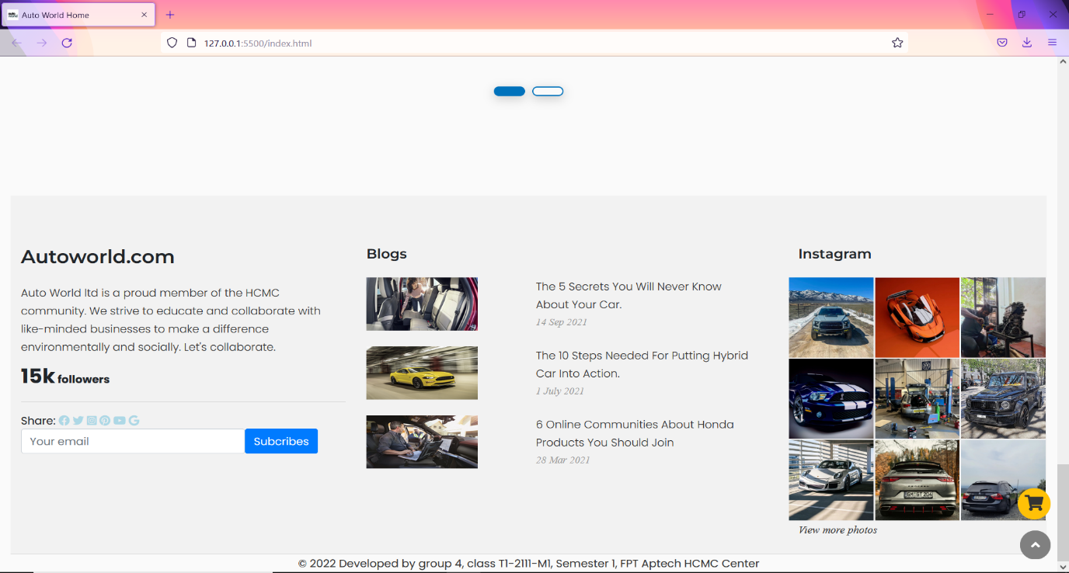

## Cart and Payment:

The following snapshot illustrates the creation of Autoworld.com cart container and payment session:

## 

## 

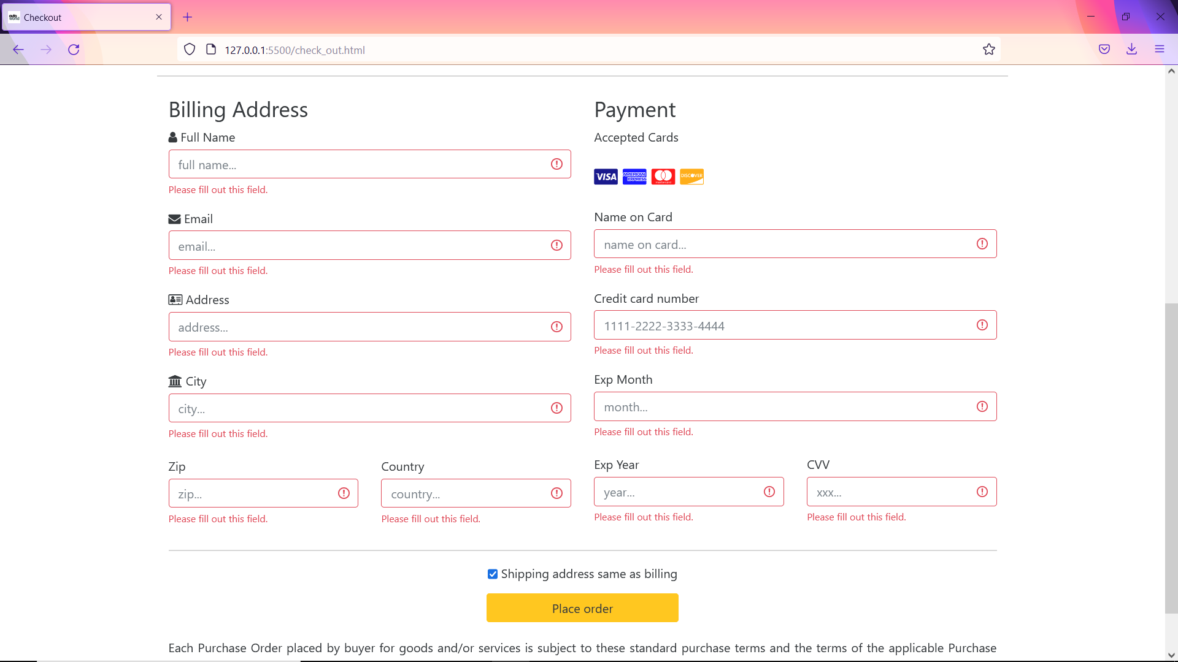

## Financial Support:

The following snapshot illustrates the creation of Autoworld.com loan service session:

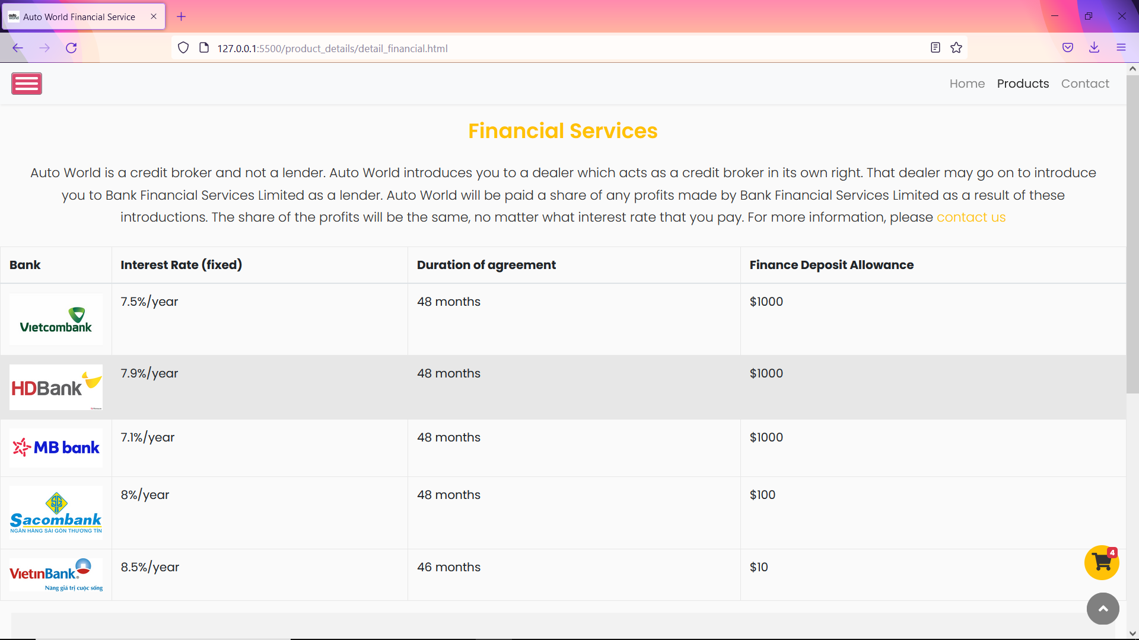

## Login and Sign Up:

The following snapshot illustrates the creation of Autoworld.com user login session, please note because lack of back-end server so it still can’t function:

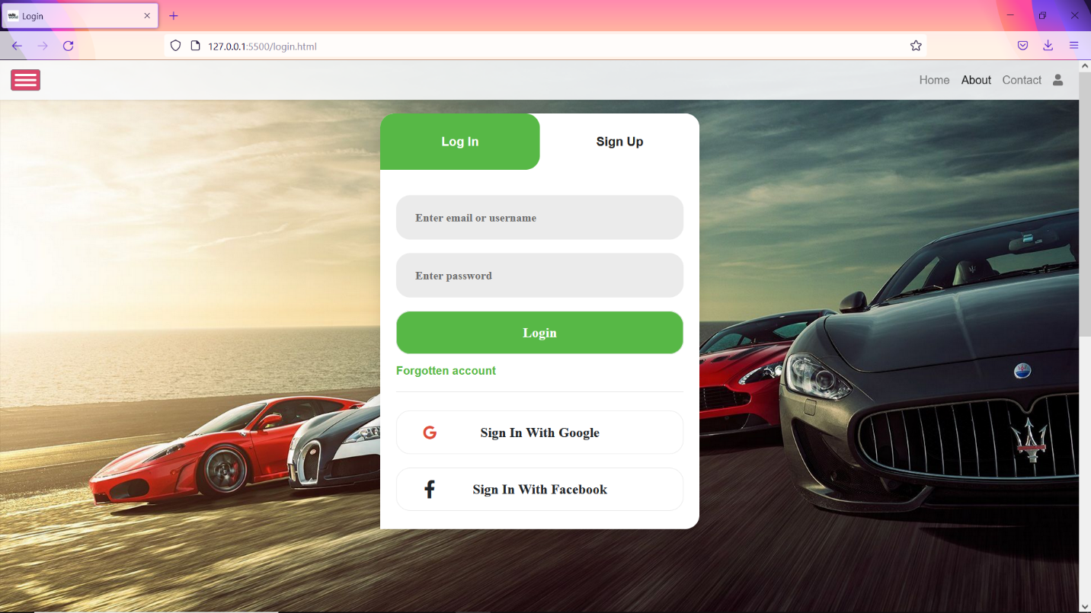

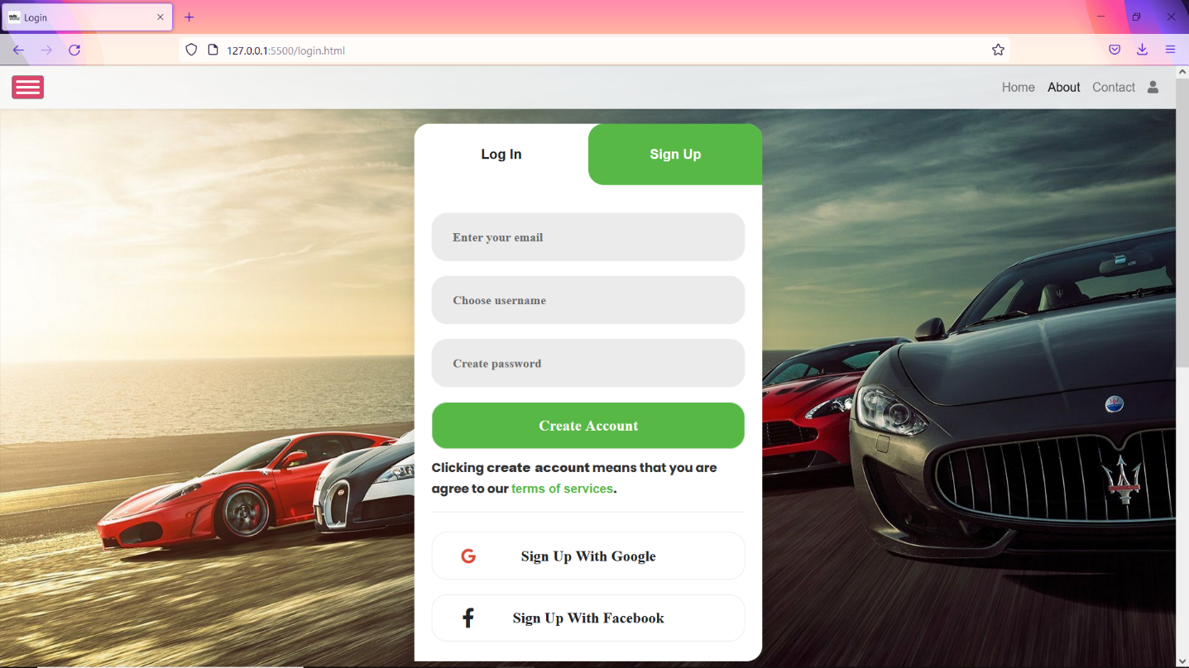

# TASK SHEET 2

|  |  |  |  |  |  |  |
| --- | --- | --- | --- | --- | --- | --- |
| **Project Ref No.** | **Project Title – Auto World** | **Activity Plan Prepared**  **by** | **Date of preparation of Activity Plan** | | | |
| **Task** | **Actual Start Date** | **Actual Days** | **Teammate Names** | **Status** |
| Brainstorming ideas for layouts and Project  Objectives. | | Lộc, Quốc | 02/03/2022 | 1 day | Lộc, Quốc | Completed |
| Draw site maps and  architecture design. | | Lộc | 02/03/2022 | 1 days | Lộc | Completed |
| Wire framing general page  layout. | | Quốc | 06/03/2022 | 4 days | Quốc | Completed |
| Collect static assets (pictures,  mp4, documentation) | | Lộc, Quốc | 08/03/2022 | 3 days | Lộc, Quốc | Completed |
| Design & Build Home Page. | | Lộc, Quốc | 11/03/2022 | 7 days | Lộc, Quốc | Completed |
| Design & Build Contact Us  Page. | | Lộc, Quốc | 19/03/2022 | 2 days | Lộc, Quốc | Completed |
| Design & Build About Us  Page. | | Lộc, Quốc | 21/03/2022 | 2 days | Lộc, Quốc | Completed |
| Design & Build Footer  Session. | | Lộc, Quốc | 23/03/2022 | 2 days | Lộc, Quốc | Completed |
| Design & Build Product Detail Pages. | | Lộc, Quốc | 25/03/2022 | 2 days | Lộc, Quốc | Completed |
| Write project report Review 1 | | Lộc | 26/03/2022 | 2 days | Lộc | Completed |
| Testing UI. | | Lộc, Quốc | 26/03/2022 | 2 days | Lộc, Quốc | Completed |
| Testing Responsiveness. | | Lộc, Quốc | 26/03/2022 | 2 days | Lộc, Quốc | Completed |
| Final Testing. | | Lộc, Quốc | 27/03/2022 | 2 days | Lộc, Quốc | Completed |
| Write project report Review 2 | | Lộc | 28/03/2022 | 3 days | Lộc | Completed |

# CHECKLIST VALIDATION

|  |  |  |
| --- | --- | --- |
| **Task**  **No.** | **Requirement** | **Validation** |
| 1 | The Home Page should be neatly created with proper logo, menu and images. | Yes |
| 2 | A menu which will include all the functions implemented in the site. | Yes |
| 3 | The user should be able to locate the dealers based on the car brands. e.g. Honda, Suzuki, Ford etc. | Yes |
| 4 | A catalogue should be provided which will help the users to have a look at car’s image and clicking on the same will display the details about it. The details include features, price, location of the dealer etc. | Yes |
| 5 | There should be a page for contacting to the company which will include the address, phone and email address. Address of the Company should be displayed using GeoLocation API (eg. GoogleMaps) and the email address which when clicked will invoke the local mail client from where they can send an email. | Yes |
| 6 | Site should also include the page that will give the information about the warranty schemes on the cars. The scheme will be different for the different brands. You are free to develop your own warranty schemes. | Yes |
| 7 | Site should also include the page that will give the information about the warranty schemes on the cars. The scheme will be different for the different brands. You are free to develop your own warranty schemes. | Yes |
| 8 | The site should also include the comparison of different cars (same as well as different brands) | Yes |
| 9 | The user should be able to search the cars based on companies and price. | Yes |
| 10 | The information about various cars can be picked up from the internet. | Yes |
| 11 | The site should have appropriate look and feel suitable to company’s reputation and status. | Yes |

# REFERENCES

1. Bootstrap 4 Tutorial. <https://www.w3schools.com/bootstrap4/default.asp>
2. Bootstrap 4 documentation. <https://getbootstrap.com/docs/4.5/getting-started/introduction/>
3. Jquery API documentation. <https://api.jquery.com/>
4. GsmArena. <https://www.gsmarena.com/>
5. W3C Schools code snippets how to. <https://www.w3schools.com/howto/default.asp>
6. 4k HD desktop wallpaper crafter. <https://wallpapercrafter.com/>
7. Owl.Carousel.js. <https://owlcarousel2.github.io/OwlCarousel2/>
8. CSS gradient color generator. Gradient backgrounds. [https://cssgradient.io/gradient- backgrounds/](https://cssgradient.io/gradient-backgrounds/)
9. Coverr free stock video footage. <https://coverr.co/>
10. Hover.css by Ian Lunn. <https://ianlunn.github.io/Hover/>
11. Pin construction animation by Nikolay Talanov. <https://codepen.io/suez/pen/doMKLP/>
12. Stackoverflown: “how to detect escape key with js”. [https://stackoverflow.com/questions/3369593/how-to-detect-escape-key-press-with-pure-js-or- jquery](https://stackoverflow.com/questions/3369593/how-to-detect-escape-key-press-with-pure-js-or-jquery)
13. W3c how to create full-screen video background. <https://www.w3schools.com/howto/howto_css_fullscreen_video.asp>
14. Smooth scrolling – CSS tricks. <https://css-tricks.com/snippets/jquery/smooth-scrolling/>
15. Restart css animation – CSS tricks. [https://css-tricks.com/restart-css- animation/#:~:text=What%20you%20really%20need%20to,itself%2C%20then%20remove%2 0the%20original.&text=This%20same%20problem%20exists%20for,but%20then%20again% 20on%20%3Ahover.](https://css-tricks.com/restart-css-animation/#%3A~%3Atext%3DWhat%20you%20really%20need%20to%2Citself%2C%20then%20remove%20the%20original.%26text%3DThis%20same%20problem%20exists%20for%2Cbut%20then%20again%20on%20%3Ahover)
16. How to change position of scroll bar using CSS – GeeksforGeeks. [https://www.geeksforgeeks.org/how-to-change-the-position-of-scrollbar-using- css/#:~:text=We%20can%20use%20CSS%20%E2%80%9C%3A%3A,position%20of%20the](https://www.geeksforgeeks.org/how-to-change-the-position-of-scrollbar-using-css/#%3A~%3Atext%3DWe%20can%20use%20CSS%20%E2%80%9C%3A%3A%2Cposition%20of%20the%20scroll%2Dbar)

[%20scroll%2Dbar.](https://www.geeksforgeeks.org/how-to-change-the-position-of-scrollbar-using-css/#%3A~%3Atext%3DWe%20can%20use%20CSS%20%E2%80%9C%3A%3A%2Cposition%20of%20the%20scroll%2Dbar)

1. Balsamiq Wire Frames. <https://balsamiq.com/wireframes/>